How Can ESG Help Businesses?

ESG can help businesses by enhancing their reputation and brand value, attracting investors and customers, mitigating risks, fostering innovation, improving operational efficiency, and driving long-term sustainable growth and profitability.
Establishing ESG Success
There is no definitive answer to who the best ESG company is since different sources may use varying criteria, methods, and data to evaluate and rank companies based on their ESG performance. ESG is a broad concept, and establishing ESG success can be challenging. However, three globally recognized providers assess companies' ESG performance.
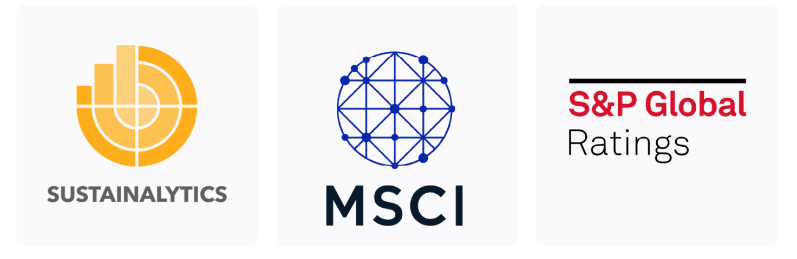
- Sustainalytics is a leading provider of ESG research, ratings, and data, helping investors and companies make informed sustainability decisions.
- MSCI is a renowned provider of ESG ratings, indexes, and analytics, offering insights for investors to integrate sustainability into their strategies.
- S&P Global is a prominent provider of ESG data and ratings, supporting investors and companies in their sustainable investment decisions.
Measuring the Value of ESG
One way to measure how well your organization is doing in regards to ESG, is to assess the environmental, social, and governance performance of companies with regard to risk. It allows for proactive risk management, informed decision-making, resource allocation, and building resilience.
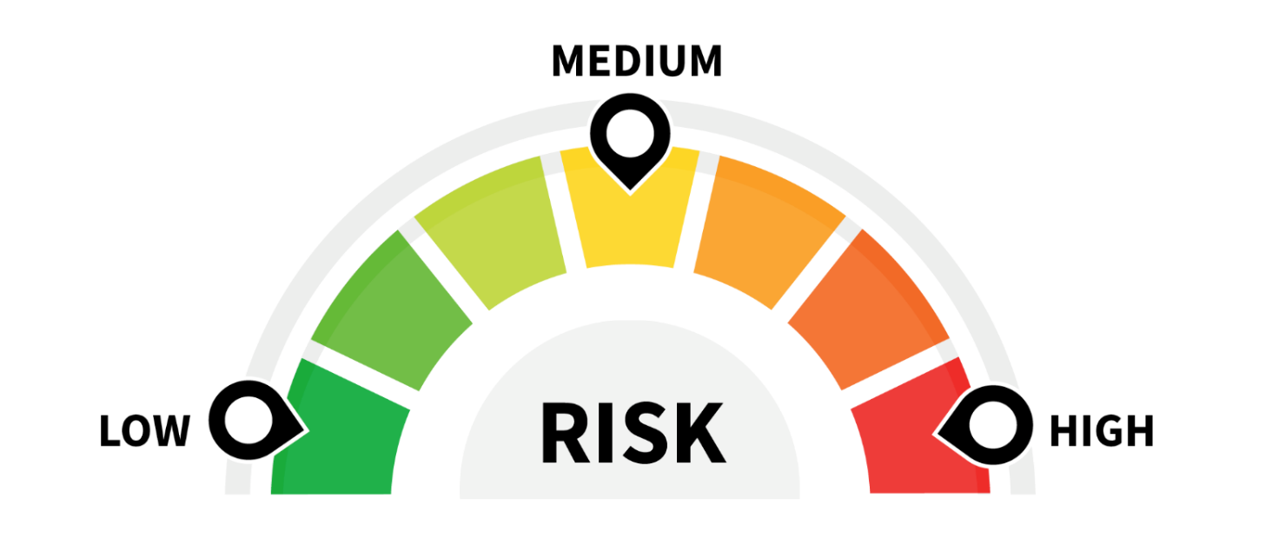
- Low Risk: Indicates that a company has demonstrated robust ESG practices by effectively managing risks and aligning with sustainable principles. Suggests that a company may have significant vulnerabilities and weaknesses in its ESG performance, potentially exposing it to reputational, regulatory, or operational risks.
- Medium Risk: Indicates a moderate level of risk, with areas for improvement and potential risks that need attention.
- High Risk: Suggests that a company may have significant vulnerabilities and weaknesses in its ESG performance, potentially exposing it to reputational, regulatory, or operational risks.
Measure Today to Improve Tomorrow
Measuring ESG progress is important because it provides a comprehensive assessment of a company's environmental, social, and governance performance. It helps track performance, identify areas for improvement, enhance transparency, build stakeholder trust, and align with sustainable business practices.
Measuring performance in terms of ESG enables us to identify gaps and vulnerabilities, empowering us to make improvements. It's important to note that even the most pioneering ESG organizations are committed to continuous improvement and consistently review their progress.

- Tesla has actively worked on addressing supply chain transparency, reducing its carbon footprint, and improving labor practices.
- Unilever announced ambitious goals to achieve a deforestation-free supply chain, reduce greenhouse gas emissions, and enhance the livelihoods of millions of people.
- Patagonia has consistently challenged itself to do better. It is currently looking at how it can collaborate with other companies, even competitors, on initiatives that would decrease the environmental footprint of the industry, particularly when it comes to carbon emissions.

